FGFR1 (V664L)
Catalog Number: CR-M 26259
Gene Symbol: FGFR1, BFGFR, CD331, CEK, FGFBR, FLG
Description: Anti-FGFR1 (V664L) Mouse Monoclonal Antibody

Background: The protein FGFR1 is highly conserved between members and throughout evolution. This particular family member of FGFR1 binds both acidic and basic fibroblast growth factors and is involved in limb induction. Mutations of FGFR1 protein have been associated with Pfeiffer syndrome, Jackson-Weiss syndrome, Antley-Bixler syndrome, osteoglophonic dysplasia, squamous cell lung cancer and autosomal dominant Kallmann syndrome.
Immunogen: A synthetic peptide from the internal region of FGFR1 which includes the mutation of V664L, human origin.
Tested applications: ELISA, WB, IHC
Recommended dilutions:
ELISA: 1:1000-1:2000
WB: 1:500-1:1000
IHC: 1:50-1:100
Concentration: 1 mg/ml
Host: Mouse
Clonality: Monoclonal
Purity: Purified from ascites
Format: Liquid
Storage buffer:
Preservative: no
Constituents: PBS (without Mg²⁺ and Ca²⁺), pH 7.4, 150 mM NaCl, 50% glycerol
Species Reactivity: Recognizes V664L mutant, but not wild-type FGFR1 of vertebrates.
Storage Conditions: Store at -20°C. Avoid
freeze / thaw cycles.

Western blot:
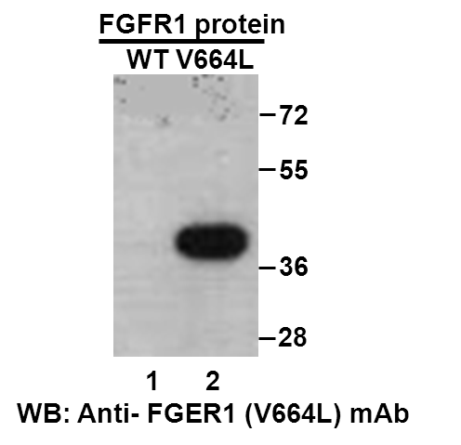
Western blot analysis of recombinant FGFR1 (V664L) and wildtype proteins. Purified His-tagged FGFR1 (V664L) protein (478-767aa, 38KD, lane 2,) and corresponding wildtype protein (lane 1) were blotted with anti-FGFR1 (V664L) monoclonal antibody (Cat. #26259).

Immunofluorescence:
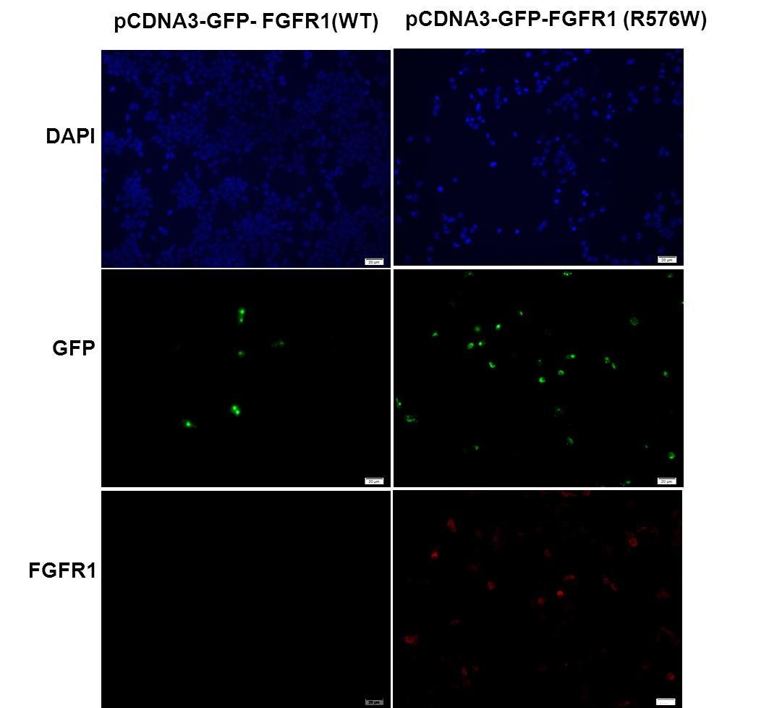
Immunofluorescence of cells expressing FGFR1 proteins with anti-FGFR1 (V664L) antibody. HEK293T cells were transfected with pCDNA3-GFP-FGFR1 (WT) plasmid (left column) or pCDNA3-GFP-FGFR1 (V664L) plasmid (right column), then fixed and stained with anti-FGFR1 (V664L) monoclonal antibody (Cat. #26259).

科博瑞（武汉）生物科技有限公司
TEL：027-87615885 15972062685
- mail：3636901710@qq.com
Web:www.coburybio.com

